# Edit email and microsite text

1. Login to Studio
2. Select Account “Adv (7b – 2016)”
3. Open Program “apcQuickStart (3)”
4. Click “Collaborate -> Enable Editing -> Program”
5. Click “Rules”
6. There are two rule groups to edit:

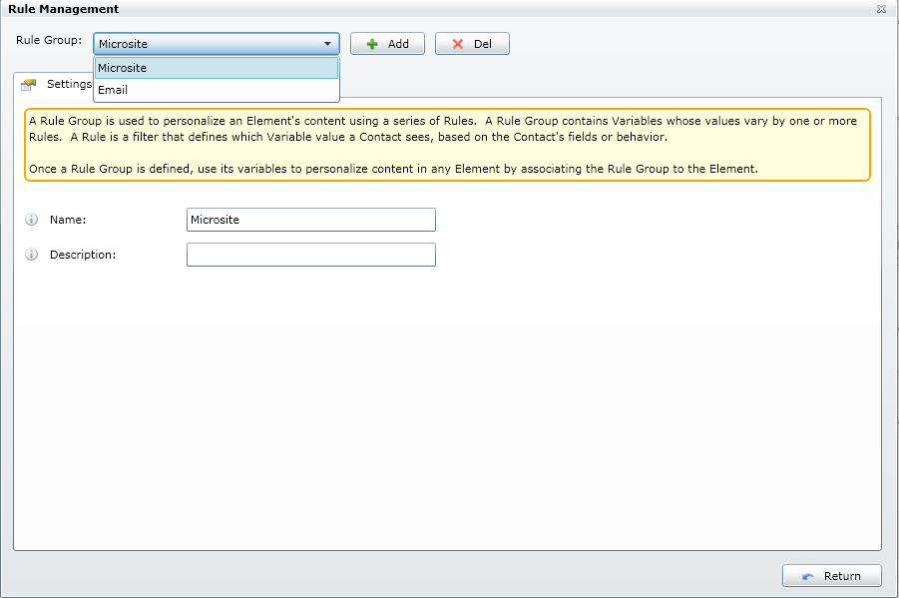

1. Select “Microsite”
2. Select Tab “Variables”

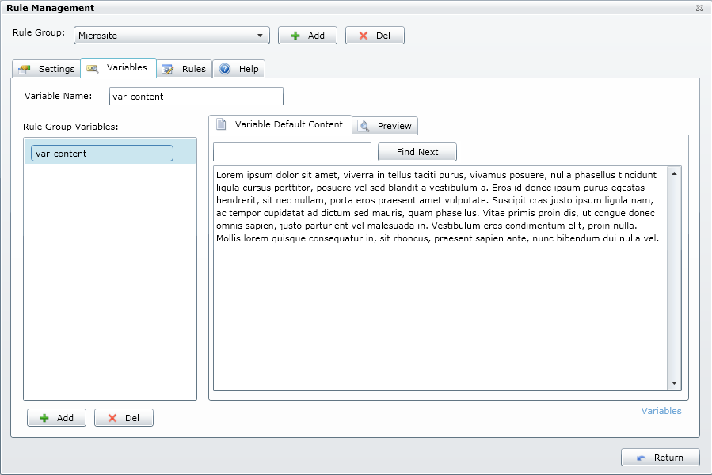

1. Select “var-content” then overwrite new text into the window.
2. Select “Email” from Rule Group:

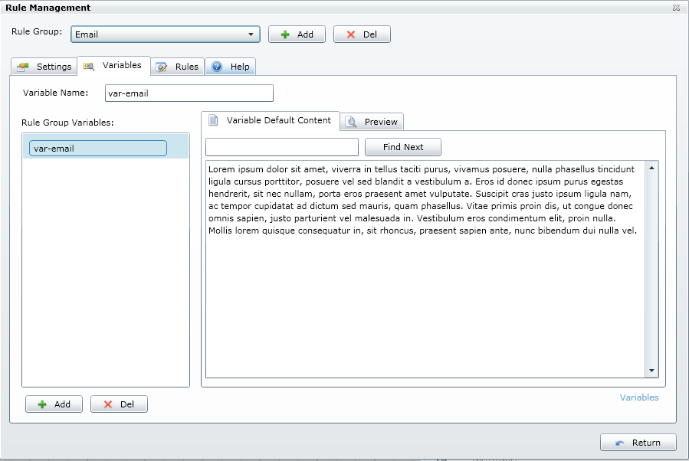

1. Select “var-email” and then edit the text in the window.
2. Click “Return”

# Select the Target Audience and Schedule the Email

1. Double-click on “Audience” element.  
     
   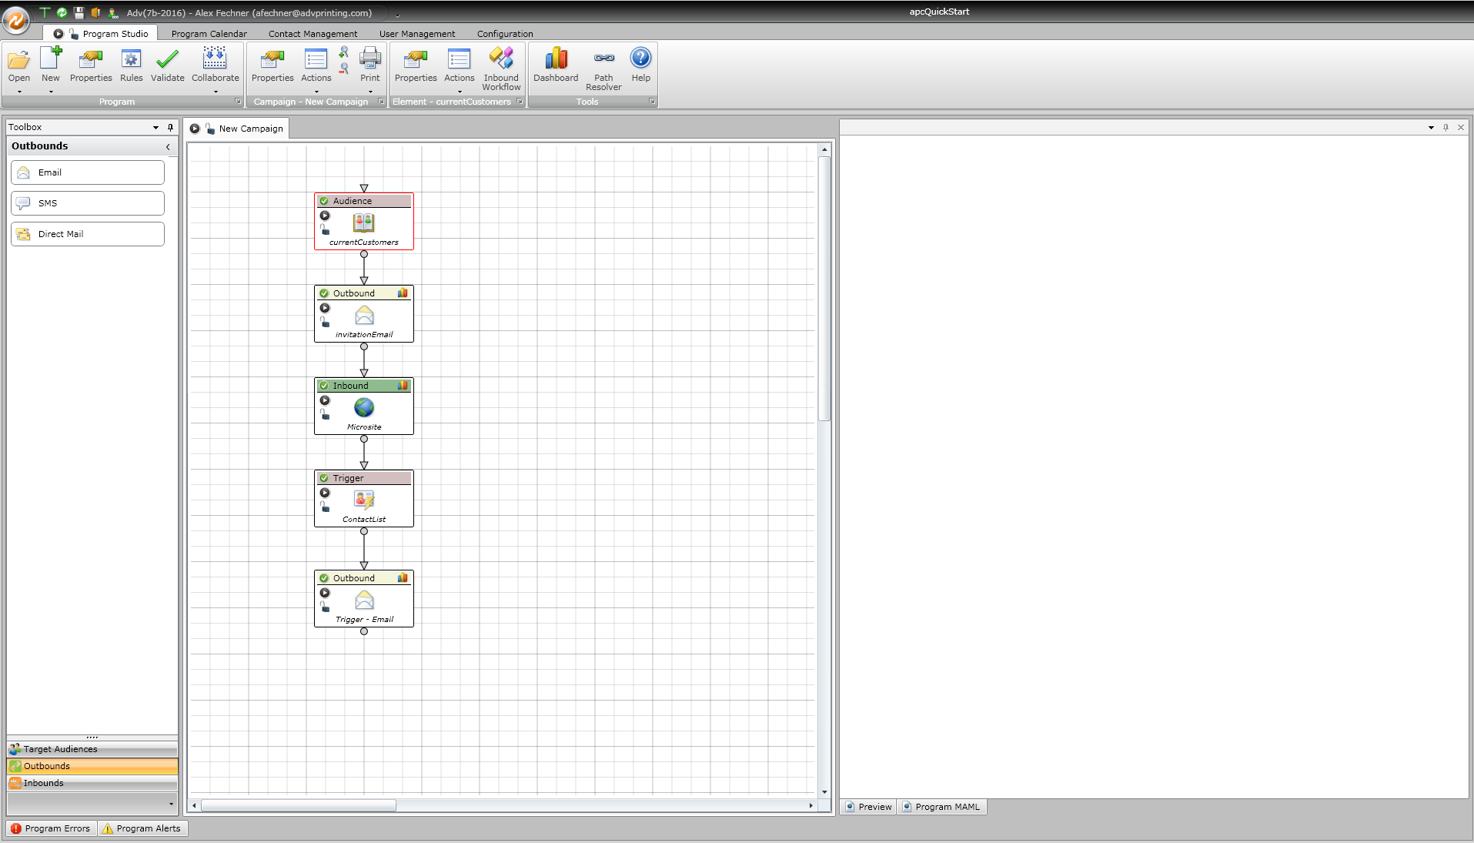
2. Select a subset of the database by creating a Segmentation filter:  
     
   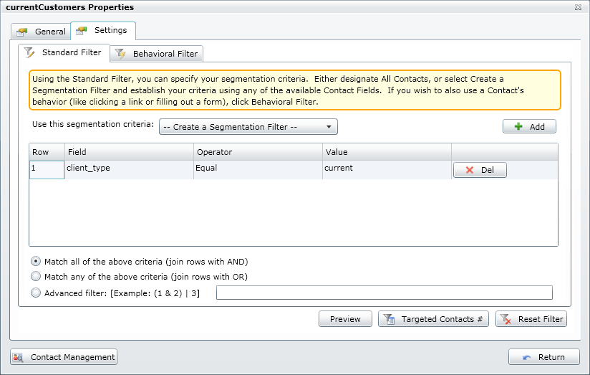
3. Double-Click “Outbound – invitationEmail”  
     
   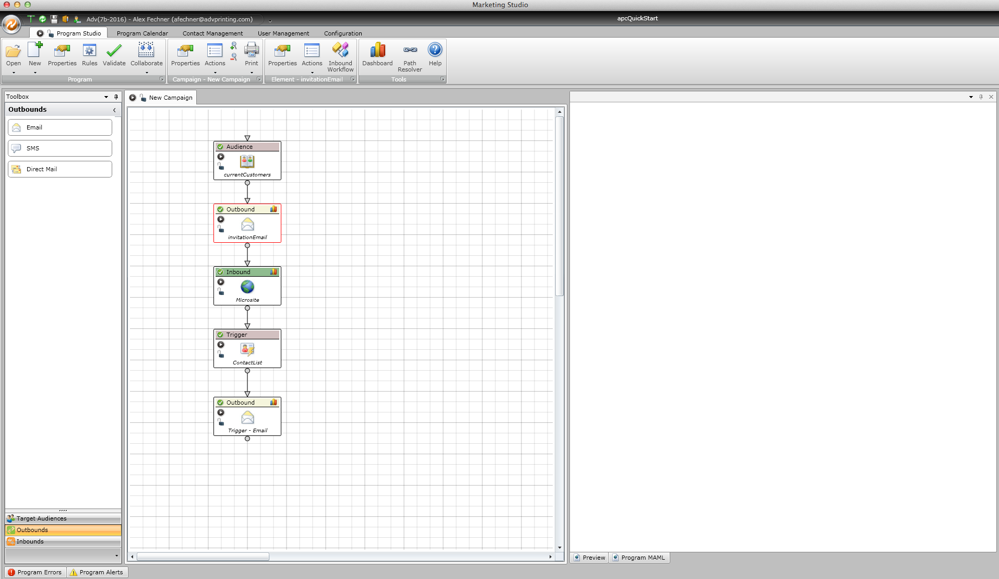
4. Click “Schedules” and then click “Add”  
     
   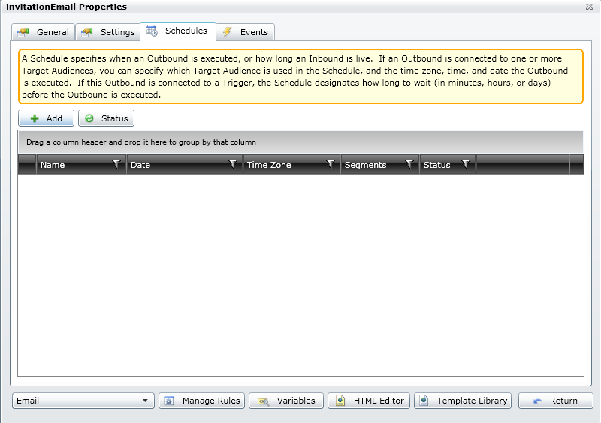
5. Define a schedule.  
     
   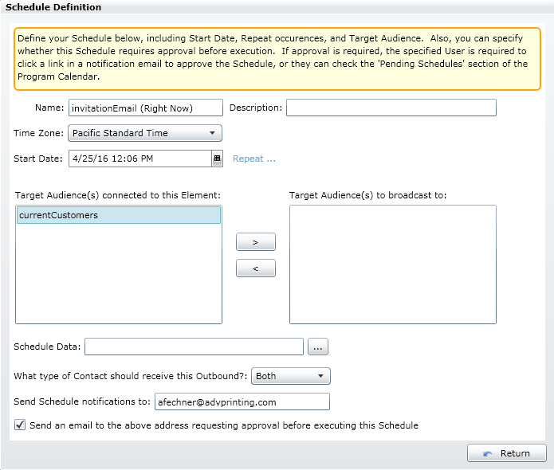

Select the Target Audience from the left pane and move it to the right pane by clicking on the shift button.

Specify date and time.

1. If you do not wish to receive an approval email prior to execution then uncheck the box. Then keep clicking “Return” to exit all the windows.
2. Click “Collaborate -> Publish Edits”.
3. All done!

# Edit the Image on the Microsite

1. Open your web browser and visit the following purl:  
   <http://alexfechner.apcquickstart.m.mdl.io>
2. Click on “Choose File” button. *Note: some browsers display “Browse”  
     
   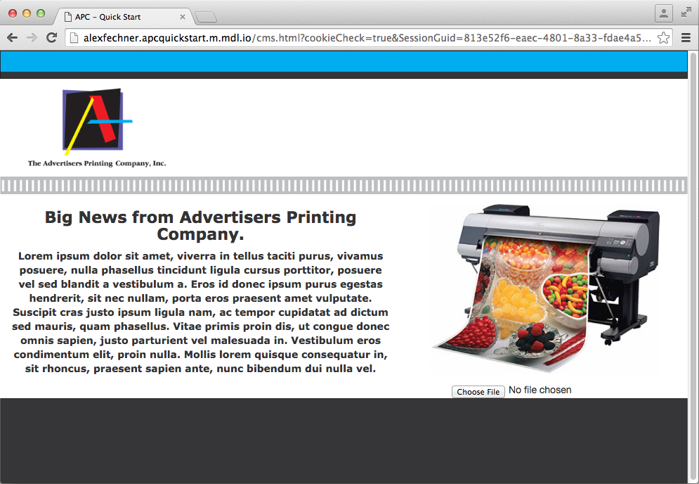
3. A file chooser window will appear. Navigate to the file you wish to use as the new image and click “Open”.  
     
   *Note: Supported file type is .jpg only. An error response will notify when selecting an invalid file type. Images will automatically be resized, but not compressed. A good rule is to keep image sizes below 500KB. The larger the file size the longer it takes to load!
4. All done! Happy email marketing ☺